**Q:- Local Procedure to calculate the sum of two number.**

DECLARE

--Local procedure to calculate the sum of two numbers

PROCEDURE calculate_sum (num1 IN NUMBER, num2 IN NUMBER) IS

BEGIN

DBMS_OUTPUT.PUT_LINE('Sum of ' || num1 || 'and' || num2 || 'is:' || (num1+num2));

END calculate_sum;

BEGIN

--Calling the local procedure

calculate_sum(10,20); -- Sum of 10 and 20

calculate_sum(50,30); --Sum of 50 and 30

END;

/

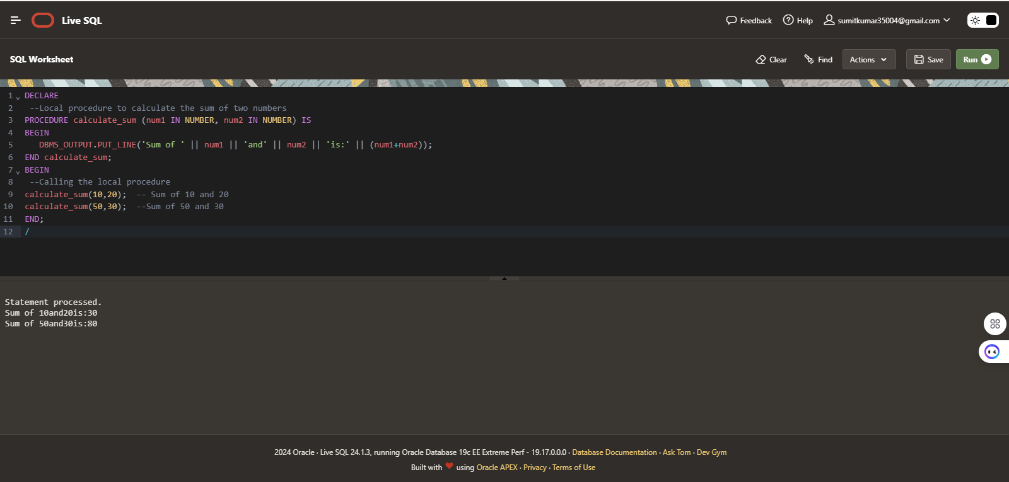

**Q:- stored procedure to calculate the sum**

CREATE OR REPLACE PROCEDURE calculate_sum(

num1 IN NUMBER,

num2 IN NUMBER,

result OUT NUMBER

) IS

BEGIN

result := num1 + num2;

END calculate_sum;

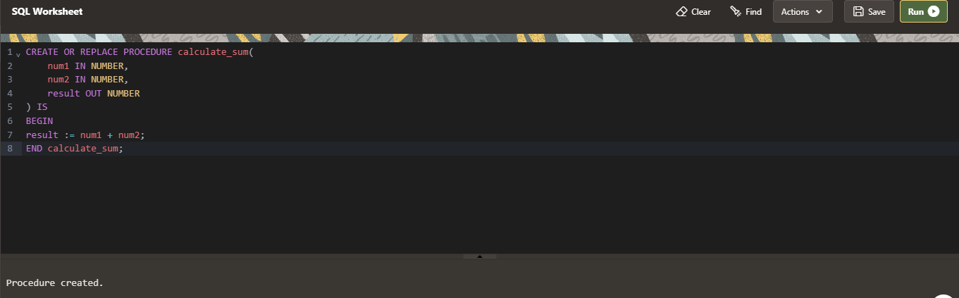

DECLARE

sum_result NUMBER;

BEGIN

calculate_sum(10, 20, sum_result);

DBMS_OUTPUT.PUT_LINE('The sum is: ' || sum_result);

END;

